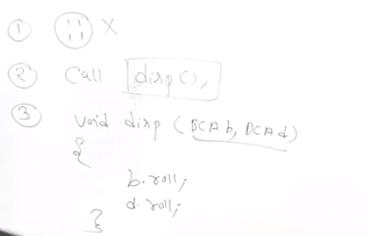

#include <iostream>

using namespace std;

// forward declaration

class B;

class A {

private:

int numA;

public:

A(): numA(12) { }

// friend function declaration

friend int add(A, B);

};

class B {

private:

int numB;

public:

B(): numB(1) { }

// friend function declaration

friend int add(A , B);

};

// Function add() is the friend function of classes A and B

// that accesses the member variables numA and numB

int add(A objectA, B objectB)

{

return (objectA.numA + objectB.numB);

}

int main()

{

A objectA;

B objectB;

cout<<"Sum: "<< add(objectA, objectB);

return 0;

}

#include <iostream>

using namespace std;

class B; //declaration of class B

class A

{

int value;

public:

A()

{

value = 5;

}

friend int sum(A, B); // declaring friend function

};

class B

{

int value;

public:

B()

{

value = 3;

}

friend int sum(A, B); // declaring friend function

};

int sum( A v1, B v2 ) // friend function definition

{

return (v1.value + v2.value);

}

int main()

{

A a;

B b;

cout << "Sum : " << sum( a, b ) << endl;

return 0;

}

#include<iostream.h>

class RectangleTwo;

class RectangleOne

{

int L,B;

public:

RectangleOne(int l,int b)

{

L = l;

B = b;

}

friend void Sum(RectangleOne, RectangleTwo);

};

class RectangleTwo

{

int L,B;

public:

RectangleTwo(int l,int b)

{

L = l;

B = b;

}

friend void Sum(RectangleOne, RectangleTwo);

};

void Sum(RectangleOne R1,RectangleTwo R2)

{

cout<<"\n\t\tLength\tBreadth";

cout<<"\n Rectangle 1 : "<<R1.L<<"\t "<<R1.B;

cout<<"\n Rectangle 2 : "<<R2.L<<"\t "<<R2.B;

cout<<"\n -------------------------------";

cout<<"\n\tSum : "<<R1.L+R2.L<<"\t "<<R1.B+R2.B;

cout<<"\n -------------------------------";

}

void main()

{

RectangleOne Rec1(5,3);

RectangleTwo Rec2(2,6);

Sum(Rec1,Rec2);

}

